Overview of Deliverable 1 Project Tasks

Diagrams (Architecture, UML, Use Case etc.)

Part A:
1. High-Level Architecture Diagram
This should be a block/component diagram showing your system, external hardware, users, and the partner system (Monitoring System). It must clearly mark the system boundary between the ADC and the Monitoring System.

Key element to include: The boundary line separating the ADC from the Monitoring System, with labelled arrows showing data exchanges (e.g., Inventory Updates, Alarms, Status).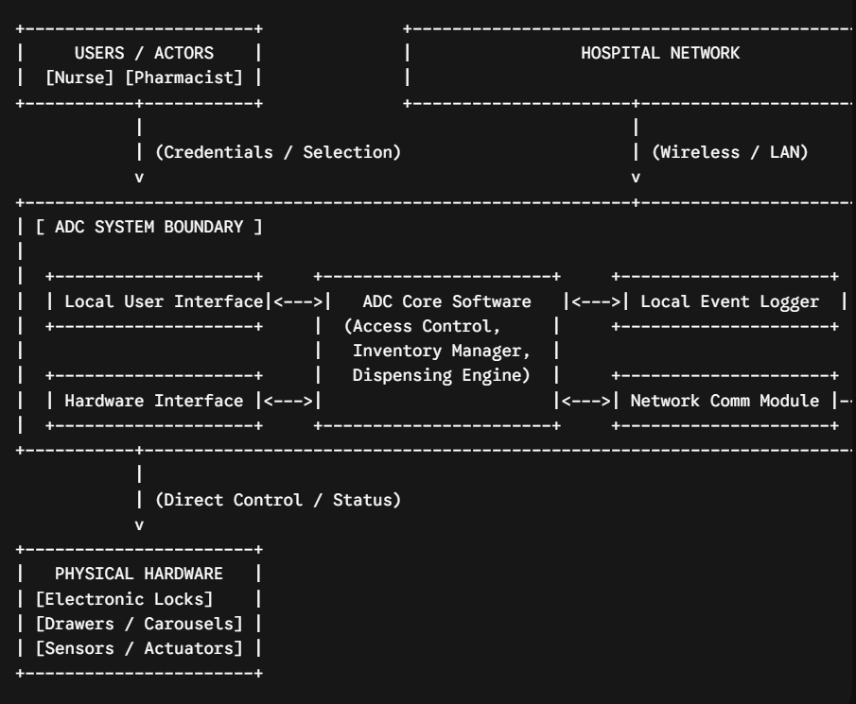
Key element to include: The boundary line separating the ADC from the Monitoring System, with labelled arrows showing data exchanges (e.g., Inventory Updates, Alarms, Status).

2. Conceptual Domain / Class Model (Structure)
At this analysis stage, you do not need full code-level attributes or methods. Focus on the main real-world concepts and how they relate.
- Classes & Attributes (Examples):
  - User: userId, role, pinHash
  - Cabinet: cabinetId, location, operationalStatus
  - Drawer: drawerId, lockStatus, sensorState
  - Medication: medicationId, name, dosage, quantity
  - DispenseEvent: eventId, timestamp, status
  - Alarm: alarmId, severity, timestamp, description
- Relationships:
  - User (1) $→$ performs $→$ DispenseEvent (0..*)
  - Cabinet (1) $→$ contains $→$ Drawer (1..*)
  - Drawer (1) $→$ stores $→$ Medication (0..*)
  - ADC (1) $→$ triggers $→$ Alarm (0..*)
3. Use Case Diagram (Behaviour)
This outlines actors and what they can do using system boundaries and relationship tags like <<include>> or <<extend>>.
- Actors: Nurse, Pharmacist, Maintenance Technician, Monitoring System
- Use Cases:
  - Authenticate User
  - Request Medication Dispensing
  - Verify Authorization (linked via <<include>> from Request Medication)
  - Unlock Drawer (linked via <<include>> from Request Medication)
  - Handle Hardware Fault (linked via <<extend>> if a sensor detects an unclosed drawer)
  - Replenish Inventory
  - Sync Data with Monitoring System
4. Activity Diagram (Behaviour)
For activity diagrams, you must map out key scenarios (including normal paths and off-normal paths like hardware faults or network loss).
Example Flow for Scenario 1: Medication Dispensing (with Off-Normal Path):
- [Start] $→$ Nurse enters credentials at ADC.
- ADC validates credentials against local/cached database.
  - Decision Node: Valid?
    - [No] $→$ Display error, log failed attempt $→$ [End]
    - [Yes] $→$ Nurse selects patient and medication request.
- ADC checks local inventory and authorization rules.
- ADC unlocks the specific drawer/compartment actuator.
- ADC monitors drawer sensor.
  - Decision Node: Does the drawer close successfully within timeout?
    - [Yes] $→$ Update local inventory counts, record audit log event, sync with Monitoring System (if online). $→$ [End]
    - [No / Fault Path] $→$ Trigger local audible/visual alert, raise hardware fault state, log critical event. $→$ [End]
5. State Machine Diagram (Behaviour)
This shows how an entity changes states based on triggers. A great choice for the ADC is tracking its Operational Modes or a Dispensing Lifecycle.
- Operational Modes State Machine:
  - States: NormalOperation, MaintenanceMode, FaultMode, OfflineMode
  - Transitions & Triggers:
    - NormalOperation $→$ (Trigger: Hardware Error / Sensor Failure Detected) $→$ FaultMode
    - NormalOperation $→$ (Trigger: Network Connection Lost) $→$ OfflineMode
    - NormalOperation or FaultMode $→$ (Trigger: Authorized Technician Key / Command) $→$ MaintenanceMode
    - MaintenanceMode $→$ (Trigger: Maintenance Complete & Diagnostics Pass) $→$ NormalOperation

Part B:
1. High-Level Architecture Diagram
This block/component diagram shows the centralized Monitoring System, its internal software modules, human users, and its integration boundary with multiple external ADC units across the hospital network.

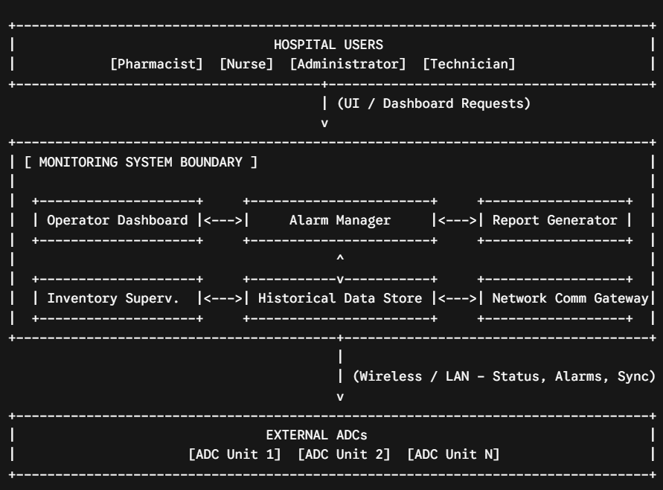
. Conceptual Domain / Class Model (Structure)
At this analysis stage, focus on the primary entities managed by the Monitoring System and how they relate to each other:
- Classes & Attributes (Examples):
  - MonitoringUser: userId, role (Pharmacist/Admin), permissions
  - MonitoredCabinet: cabinetId, location, connectionStatus, lastHeartbeat
  - Alarm: alarmId, severity, timestamp, description, state (Active/Acknowledged)
  - InventorySnapshot: medicationId, quantity, lowStockThreshold, timestamp
  - AuditReport: reportId, generationDate, parameters
- Relationships:
  - MonitoringUser (1) $→$ manages / reviews $→$ Alarm (0..*)
  - MonitoredCabinet (1) $→$ generates $→$ Alarm (0..*)
  - MonitoredCabinet (1) $→$ reports $→$ InventorySnapshot (0..*)
  - MonitoringSystem (1) $→$ tracks $→$ MonitoredCabinet (1..*)
3. Use Case Diagram (Behaviour)
This outlines actors and system capabilities using boundaries and relationship markers like <<include>>:
- Actors: Pharmacist, Administrator, Technician, ADC Unit (External Actor)
- Use Cases:
  - Monitor Operator Dashboard
  - Supervise Inventory (linked via <<include>> from Dashboard)
  - Manage Alarms (e.g., Acknowledge or Dismiss Alarms)
  - Review Historical Data
  - Generate Operational Reports
  - Receive ADC Telemetry & Events (triggered by external ADC Unit)
  - Monitor Cabinet Health (linked via <<include>> from Handle Communication Failure)
4. Activity Diagram (Behaviour)
This maps out operational workflows, including normal paths and off-normal failure paths (e.g., handling communication loss or incoming alarms).
Example Flow for Scenario: Alarm Reception & Processing:
- [Start] $→$ Monitoring System receives an incoming alarm payload from an ADC unit via the network gateway.
- System parses the alarm data and logs it into the historical data store.
- System checks the severity level of the alarm.
  - Decision Node: Is the severity critical (e.g., hardware fault, security breach)?
    - [Yes] $→$ Trigger high-priority visual alert on the Operator Dashboard and sound an audible notification for active staff.
    - [No] $→$ Log standard alert notification in the background task queue.
- Operator views and acknowledges the alarm on the dashboard.
- System updates the alarm status to "Acknowledged", records the user ID and timestamp, and syncs status back if needed. $→$ [End]
5. State Machine Diagram (Behaviour)
This captures state-dependent behaviour. A great choice for Part B is tracking the Cabinet Connection Status Lifecycle across the network.
- Cabinet Connection Lifecycle State Machine:
  - States: Online, Degraded, Offline, MaintenanceMode
  - Transitions & Triggers:
    - Online $→$ (Trigger: Heartbeat timeout threshold exceeded / Ping failed) $→$ Offline
    - Offline $→$ (Trigger: Heartbeat re-established from ADC) $→$ Online
    - Online $→$ (Trigger: Packet loss or high latency detected) $→$ Degraded
    - Degraded $→$ (Trigger: Connection stabilized) $→$ Online
    - Any State $→$ (Trigger: Administrator toggles manual maintenance lock) $→$ MaintenanceMode

Functional Requirements:

Part A: Automated Dispensing Cabinet (ADC)
Functional Requirements (Examples)
- FR-ADC-01 (Authentication): The ADC software shall verify user credentials (e.g., PIN, smart card, biometric) prior to unlocking any medication storage drawer.
- FR-ADC-02 (Dispensing): The ADC software shall unlock only the specific drawer and compartment corresponding to an authorized medication request.
- FR-ADC-03 (Inventory Update): The ADC software shall automatically decrement local inventory counts immediately after a medication is successfully dispensed and confirmed.
- FR-ADC-04 (Fault Detection): The ADC software shall detect if a drawer fails to close within a predefined timeout threshold and trigger a local sensor fault state.
- FR-ADC-05 (Offline Operation): The ADC software shall continue to execute local dispensing, access control, and local event logging when network communication with the Monitoring System is lost.
User Story Example
- User Story:
As a Nurse,
I want to authenticate at the ADC and select a patient medication request,
So that I can safely and securely retrieve the correct medication dose.
- Acceptance Criteria (Gherkin format):
  - Given the nurse is standing at the ADC home screen,
  - When the nurse enters valid credentials and selects an authorized prescription,
  - Then the system shall verify authorization, unlock the corresponding drawer, and record an audit log entry.

Part B: Hospital Monitoring System
Functional Requirements (Examples)
- FR-MON-01 (ADC Communication): The Monitoring System shall establish and maintain a secure network connection to receive regular telemetry and event streams from multiple active ADC units.
- FR-MON-02 (Alarm Management): The Monitoring System shall receive, parse, and display real-time alarms generated by any connected ADC unit on the operator dashboard.
- FR-MON-03 (Inventory Supervision): The Monitoring System shall aggregate and display inventory status across all deployed ADCs to help pharmacy personnel identify low-stock items.
- FR-MON-04 (Cabinet Health Monitoring): The Monitoring System shall track the connection status of each ADC via periodic heartbeats and flag a cabinet as "Offline" if a heartbeat is missed.
- FR-MON-05 (Historical Data Retrieval): The Monitoring System shall store historical logs of dispensing activities and alarms, allowing authorized staff to query past events.
User Story Example
- User Story:
As a Pharmacist,
I want to view a centralized operator dashboard showing live inventory and alarm statuses for all connected ADCs,
So that I can identify which cabinets require inventory replenishment or immediate maintenance.
- Acceptance Criteria (Gherkin format):
  - Given the pharmacist is logged into the Monitoring System dashboard,
  - When an ADC unit flags a low-stock inventory level or raises a hardware alarm,
  - Then the Monitoring System shall instantly update the dashboard display to highlight the affected cabinet and log the event into the historical database.

Part A: Automated Dispensing Cabinet (ADC) Traceability Table
Requirement ID | Associated User Story Summary | Architecture Component | Stakeholder / Source
FR-ADC-01 | US-ADC-01: Nurse authenticates to request medication | Local User Interface / ADC Core Software | Nurse / Project Scope Sec. 6
FR-ADC-02 | US-ADC-01: System unlocks specific compartment | ADC Core Software / Hardware Interface | Nurse / Scenario 1
FR-ADC-03 | US-ADC-02: Local inventory decrements after dispensing | ADC Core Software | Pharmacist / Scenario 2
FR-ADC-04 | US-ADC-03: System detects unclosed drawer timeout | Hardware Interface / ADC Core Software | Technician / Scenario 3
FR-ADC-05 | US-ADC-04: System continues local operation offline | Network Comm Module / ADC Core Software | Administrator / Scenario 4

Part B: Hospital Monitoring System Traceability Table
Requirement ID | Associated User Story Summary | Architecture Component | Stakeholder / Source
FR-MON-01 | US-MON-01: System receives telemetry from multiple ADCs | Network Comm Gateway | Administrator / Part B Sec. 6
FR-MON-02 | US-MON-02: Operator views real-time hardware alarms | Alarm Manager / Operator Dashboard | Pharmacist / Scenario 2
MON-03 | US-MON-03: Pharmacist supervises multi-cabinet inventory | Inventory Supervision / Dashboard | Pharmacist / Scenario 1
FR-MON-04 | US-MON-04: System flags disconnected or offline cabinets | Operator Dashboard / Gateway | Technician / Scenario 3
FR-MON-05 | US-MON-05: Pharmacist queries past audit logs and events | Historical Data Store | Pharmacist / Scenario 4

